Authoring Environment Setup Guide

## Prerequisites

1. Download GitHub Desktop [Here](https://desktop.github.com/)
2. [Install it](https://services.github.com/on-demand/github-desktop/install-github-desktop)
3. Sign Up with Bitbucket Online

Your existing ParTech account (if you have one) will not work until DevOps links the online repository with Active Directory or provides an alternate repository.

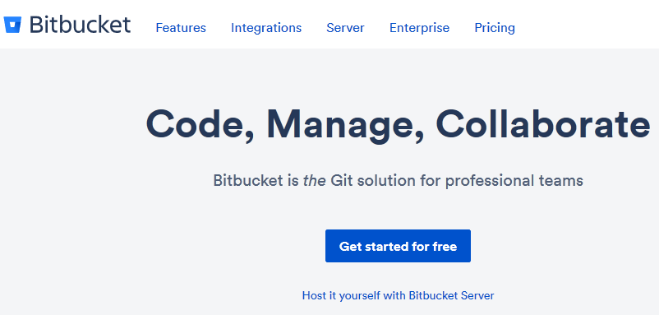

1. Give Joseph your username so he can add you to the account until DevOps can provide an official repository
2. Access the parkbs repository
3. Get the link to clone the repository via HTTPS

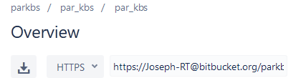

1. Clone the repository using GitHub Desktop

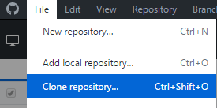

(Shown Below)

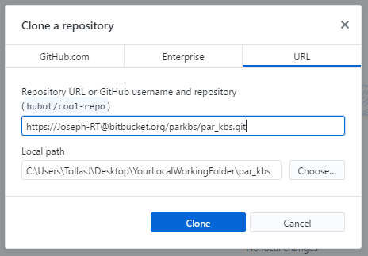

1. Choose or create a local working directory and hit ‘Clone’
2. Add articles & their images to the local repository you just created on your computer

Note: Do not use a OneDrive directory if access to that is setup through Windows Explorer. This works most of the time but causes files to duplicate in OneDrive in certain circumstances.

## Text Editor Recommendations:

For those needing suggestions on text editors, a brief list has been compiled below.

Anything built for writing in markdown specifically is best, and therefore recommended.

**Typora** <http://typora.io> Recommended

Free while in Beta, and a favorite of many. Designed for writers (not programmers), it comes packed with features such as a built-in Markdown reference and drag n’ drop for images.

## Alternative Editors

**Built-in Admin Interface**

Through the Jekyll development/testing environment: Bundle exec Jekyll serve --> <http://localhost:4000/admin>

**Bitbucket Online: Built-in Source File Editor**

Bitbucket > KBS repo > Source > [choose folder] > [choose branch] > 'New File' > Give the title and extension of .md

**Caret** <http://caret.io> ($30)

**Notepad.exe**

Hailing from 1983, it's as close as you can get to writing with a chisel - without damaging your screen.

**Dillinger.io** <http://dillinger.io>

Online Only

**StackEdit** <https://stackedit.io/>

Online Only

**iA Writer** <https://ia.net/writer/>

Available for purchase on the Mac App Store

Free on Android via Google Play Store

apparently still 'too good' for the Windows Store

**Why Not Use [Favorite Word Processor]?**

See the section: [Plain text files vs. word processor files](https://en.wikipedia.org/wiki/Text_editor)

In short, it adds a bunch of invisible binary format encoding to the file contents, thus not plaintext.

# Learn More

**Source / Version Control for Writers**

Read:

[Version Control eBook](https://www.git-tower.com/learn/git/ebook/en/desktop-gui/basics/basic-workflow#start)

[Vocabulary of GitHub for Documentation](https://www.docslikecode.com/articles/github-for-docs/)

[In Plain English](https://blog.red-badger.com/blog/2016/11/29/gitgithub-in-plain-english)

[Learn with Bitbucket](https://www.atlassian.com/git/tutorials/learn-git-with-bitbucket-cloud)

[Learn with GitHub](https://services.github.com/on-demand/resources/videos/)

Watch:

[GitHub Desktop](https://www.youtube.com/watch?v=_qXXAWsxldg)

[GitHub Videos](https://services.github.com/on-demand/resources/videos/)

Tutorials:

[Workflow](https://guides.github.com/introduction/flow/index.html)

**Learning Markdown**

Read:

[GitLab Authoring Guide](https://about.gitlab.com/handbook/product/technical-writing/markdown-guide/)

[Markdown Cheat Sheet](https://guides.github.com/pdfs/markdown-cheatsheet-online.pdf)